PRODUCT FEATURE

Unlock Seamless Integration:
Introducing the CUT-4 Logic Interface by Clockaudio
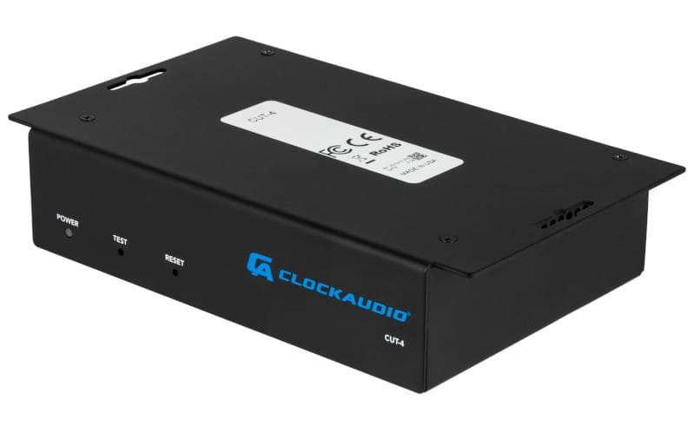
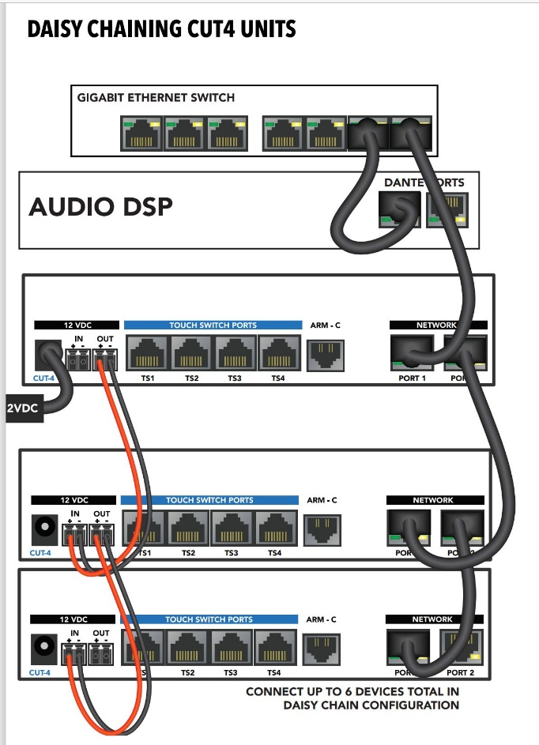
Introducing the latest innovation from Clockaudio: the CUT-4 logic interface. Engineered to seamlessly integrate with Clockaudio's LED buttons, including the RGB TS Touch Switches (TS003/TS005), the CUT-4 opens up a world of possibilities for control and customization.
With the ability to connect to your favorite DSP or control system over a network, the CUT-4 empowers users to effortlessly manage their audio environment with precision and ease.

Designed to accommodate up to 4 TS buttons, the CUT-4 offers unparalleled flexibility and control. Each TS port boasts 3 logic inputs and 3 logic outputs, providing a total of 12 logic inputs and 12 logic outputs per device. But that's just the beginning – with 256 levels of brightness per color, the CUT-4 boasts millions of possible color combinations, allowing users to tailor their setup to their exact specifications.

Equipped with two gigabit ports for daisy chaining, the CUT-4 enables seamless scalability and integration.
With the ability to connect up to 6 CUT-4 devices on a single network run back to the rack, users can enjoy a total of 72 inputs and 72 outputs per cable run – perfect for even the most demanding audio environments.

From boardrooms to broadcast studios, the CUT-4 sets a new standard for control and customization. With its advanced features and intuitive design, it's the perfect solution for any application where precision and reliability are paramount.
Experience the power of the CUT-4 and unlock a new level of control over your audio environment today.

AT A GLANCE – CUT4 LOGIC INTERFACE
- Easy to install with under-table mounting
- Control logic transported via UDP messages over the network
- 4 RJ45 Touch Switch ports compatible with all logic-enabled Clockaudio devices including:
  - direct connection to TS003, TS005, CRM202S-RF, CRM203S-RF, CS-S Series, SM80S, S80S & SWP-2
  - direct connection to ARM-C controller & CCRM4000 Retractable Microphone
- Open API for interfacing with Control Systems
- Compatible with most DSPs and Control systems
- Power Supply for the CUT4 is sold separately.
NEED MORE INFO?
Check out the user manual here.
Click for our Quick Start instructions.
As always, if you have any questions, contact our customer service and technical support team for additional information and insight. Reach us at 1-888-424-9797 or at info@clockaudio.com.

