PRESS CONTACT FOR IMMEDIATE RELEASE
Crystal Vision Marketing
Attn: Jodi Jacobs
For Questions: 631.609.7183
jodi@crystalvisionmktg.com
Effortless Audio Environment Management
With Clockaudio’s CUT4 Logic Interface
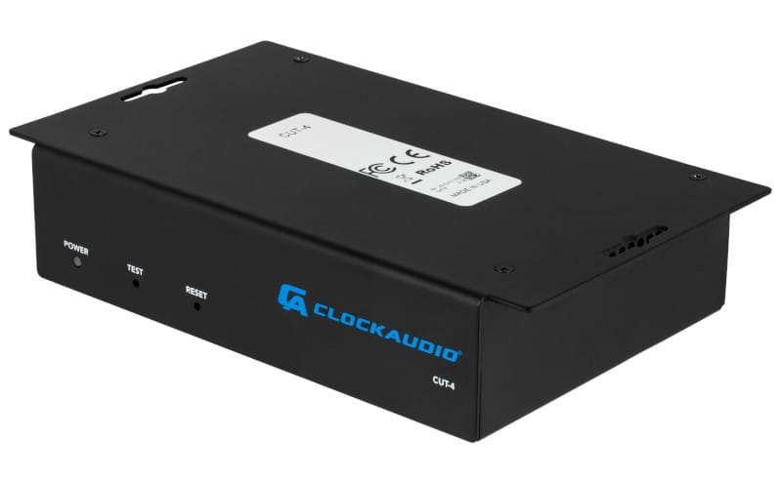
April 1, 2024 - Montreal, Canada – Clockaudio N.A., a global leader in pro-av microphone technologies is pleased to announce the immediate availability of its latest integration solution, the CUT-4 Logic Interface, designed to streamline installation and configuration with its plug and play platform.
The CUT-4 Logic Interface represents the newest innovation from Clockaudio, catering to the needs of integrators seeking seamless integration solutions. Engineered specifically to work in harmony with Clockaudio's LED buttons, including the popular RGB TS Touch Switches, the CUT-4 opens up a world of possibilities for control and customization.
With the CUT-4, integrators gain the ability to connect to a DSP or control system over a network, empowering users to effortlessly manage their audio environment with precision and ease. Equipped with two gigabit ports for daisy chaining, the CUT-4 facilitates seamless scalability and integration, accommodating up to 4 touch switches for tremendous system flexibility.
Each touch switch port on the CUT-4 features 3 logic inputs and 3 logic outputs, providing a total of 12 logic inputs and 12 logic outputs per device. Additionally, with 256 levels of brightness per color, the CUT-4 offers millions of possible color combinations, allowing users to tailor their setup to their exact specifications.

Furthermore, the CUT-4 allows for the connection of up to 6 devices on a single network run back to the rack, providing a total of 72 inputs and 72 outputs per cable run – ideal for even the most demanding audio environments.
Robert Moreau, Managing Director for Clockaudio, N.A., shares “From boardrooms to broadcast studios, we designed the CUT-4 to set a new standard for control and customization. With its advanced features and intuitive design, it serves as the perfect solution for any application where precision and reliability are paramount.”
To facilitate installation, the new product can be easily installed with under-table mounting. Compatible with most DSPs and control systems, the system was designed with open API. Experience the power of the CUT-4 and unlock a new level of control over your audio environment today.
Plan to join Clockaudio on the road for a close up look at this exciting product during Infocomm, June 8 – 14, 2024, in Las Vegas, NV or contact Clockaudio for an online demonstration of the product’s capabilities.
ABOUT CLOCKAUDIO
For over 25 years, Clockaudio has been dedicated to manufacturing innovative pro-audio products. With Corporate Headquarters and Manufacturing located in the United Kingdom and offices located in North America (Montreal, Canada) and Asia (Singapore), Clockaudio is led by a talented team of audio specialists dedicated to quality, service and innovation.
On a global level, audio professionals actively seek out and recommend Clockaudio for its
reputation as a trusted and responsive manufacturer and its customer driven approach to audio solutions.
Central to this is the in-house research and development that Clockaudio consistently reinvests in which allows clients to explore customized prototypes and develop specific briefs in partnership.

Consultants and contractors alike help to drive Clockaudio’s product development process and appreciate the opportunity to be involved in the engineering process and final solution. The ability to customize is just one of the many factors which makes Clockaudio clearly different. For the latest information on our new products, news and projects, visit www.clockaudio.com, follow Clockaudio on LinkedIn, Instagram, and like them on Facebook.

