PRESS CONTACT FOR IMMEDIATE RELEASE
Crystal Vision Marketing
Attn: Jodi Jacobs
For Questions: 631.609.7183
jodi@crystalvisionmktg.com
Sound Control Technologies Streamlines System Integration with New Interface for Clockaudio C303-RF
June 21, 2023 - Montreal, Canada – Clockaudio, a global leader in pro-av microphone technologies and Sound Control Technologies, the industry leader in camera and signal extension solutions, announces another collaborative effort and a new adaptor, the RM-C303, that further increases the performance value of a popular Clockaudio solution.
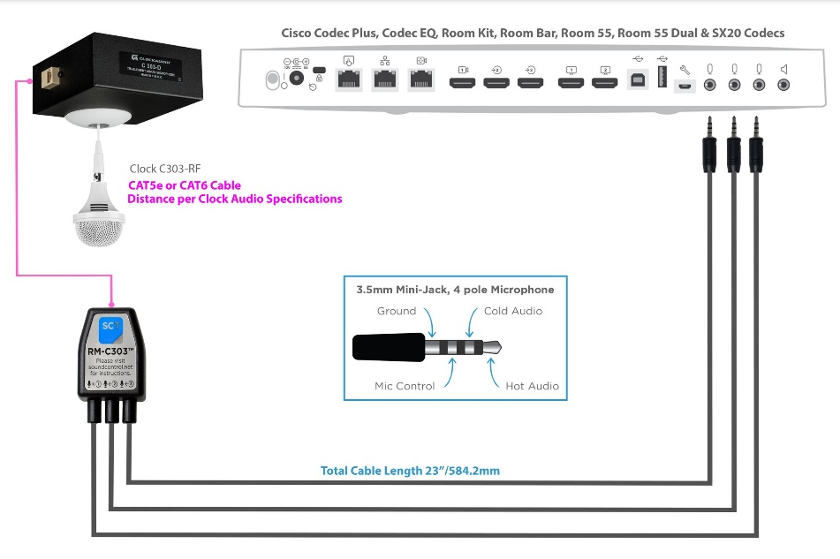
Sound Control Technologies’ RM-C303™ adaptor was designed so field techs can easily extend the C303-RF, Clockaudio’s tri-element array hanging ceiling microphone, on CAT5e or CAT6 cable, back to the Codec.
This new collaboration allows the Clockaudio C303-RF, Ceiling Microphone, to interface with a Cisco Codec via a simple plug and play Sound Control Technologies adaptor.
Shown above, the connection from Clockaudio’s C303 uses the Sound Control Technologies RM-C303™ adaptor. With it, connection is made back to the SX10/MX200/MX300/Room 55, Room 55 Dual endpoints and SX20/Codec Plus/Room Kit codecs and new Codec EQ & Room Bar.
Of the adaptor collaboration, Robert Moreau, Managing Director for Clockaudio NA, stated, “Clockaudio is always about quality audio and keeping things simple for integrators in the field. We are pleased that this new collaboration with Sound Control Technologies accomplishes this and more.”
Commenting on this latest solution, David Neaderland, President of SCT shares, ““SCT is excited to have developed the RM-C303™ solution in cooperation with Clockaudio to provide a seamless interface between the C303-RF microphone and Cisco codecs utilizing the TRRS microphone input.”
Both companies continue to look for ways to work together to streamline installation and control options to make quality audio easier to achieve and installations easier for integrators in the future.
For more on Sound Control Technologies, visit them at www.soundcontrol.net.
For the latest information on our new products, news and projects, follow Clockaudio on twitter and like them on Facebook and LinkedIn.
To learn more about Clockaudio products and innovative applications or to inquire about our rep opportunities and distributors contact info@clockaudio.com.

