PRESS CONTACT FOR IMMEDIATE RELEASE
Crystal Vision Marketing
Attn: Jodi Jacobs
For Questions: 631.609.7183
jodi@crystalvisionmktg.com
Sound Control Technologies & Clockaudio Announces New Collaboration to Simplify Audio System Control
June 21, 2023 - Montreal, Canada – Clockaudio, a global leader in pro-av microphone technologies and Sound Control Technologies, the industry leader in camera and signal extension solutions, is pleased to announce a new audio system control collaboration.
In today's fast-paced world, efficiency and simplicity are paramount. Recognizing this need, Sound Control Technologies and Clockaudio have come together to address the challenges faced by audio professionals in deploying and managing complex audio systems.
The result is a groundbreaking collaboration that eliminates the need for third-party control systems or audio Digital Signal Processors (DSPs), saving both time and money while ensuring optimal system performance.
Traditionally, setting up and controlling audio systems required extensive integration of multiple components, including control systems and DSPs, often leading to complicated and time-consuming installations. With this collaboration, however, Sound Control Technologies and Clockaudio have developed a solution that simplifies the process significantly.
With this new solution, audio professionals can now enjoy unparalleled convenience and flexibility. By leveraging Clockaudio's cutting-edge microphone technology and Sound Control Technologies' expertise, users can gain seamless control over audio systems directly from a Cisco Codec.
Of the collaboration, Robert Moreau, Managing Director for Clockaudio NA, shared, “We are thrilled about this collaboration which simplifies the connectivity between our Clockaudio microphones and the Cisco Codec through this Sound Control Technologies’ interface.”
David Neaderland, President of SCT shares, “SCT is excited to have developed the RM-C200™ solution in cooperation with Clockaudio to provide a seamless interface between the CRM 200S-RF RGB microphone and Cisco codecs utilizing the TRRS microphone input.”
Both companies see that the collaboration offers benefits beyond streamlined installation and control. With the elimination of additional equipment, potential points of failure are reduced, resulting in enhanced reliability and system stability. This means fewer troubleshooting and maintenance requirements, translating into cost savings and increased uptime.
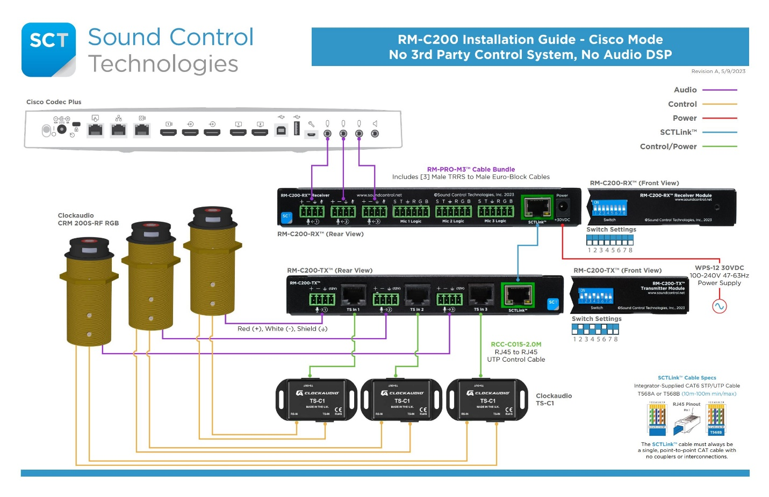
Collaboration and building strong teams are just one of the many factors which makes Clockaudio clearly different. For the latest information on our new products, news and projects, follow Clockaudio on twitter and like them on Facebook and LinkedIn.
To learn more about Clockaudio products and innovative applications or to inquire about our rep opportunities and distributors contact info@clockaudio.com.
For more on Sound Control Technologies, visit them at www.soundcontrol.net.

